 | STOCKSENSE AI
OCTOBER 2026 | PROJECT REPORT SUBMITTED IN PARTIAL FULFILLMENT OF THE REQUIREMENTS FOR THE AWARD OF THE  DEGREE OF BACHELOR OF TECHNOLOGY  IN COMPUTER SCIENCE AND BUSINESS SYSTEMS  OF THE ANNA UNIVERSITY
 | Submitted by  JASWIN D L-722824244019
  AI &ML PROJECT
  WORK
BATCH
2024 - 2028
Under the Guidance of
Dr.P.PONNI
Assistant Professor
COMPUTER SCIENCE AND BUSINESS SYSTEMS

Sri Eshwar College of Engineering
(An Autonomous Institution – Affiliated to Anna University)
COIMBATORE – 641 202

 | STOCKSENSE AI
OCTOBER 2026 | PROJECT REPORT SUBMITTED IN PARTIAL FULFILLMENT OF THE REQUIREMENTS FOR THE AWARD OF THE  DEGREE OF BACHELOR OF TECHNOLOGY  IN COMPUTER SCIENCE AND BUSINESS SYSTEMS  OF THE ANNA UNIVERSITY
 | Submitted by  JASWIN D L – 722824244019
  AI & ML
  PROJECT
  WORK
BATCH
2024 - 2028
Under the Guidance of
Dr.P.PONNI,
Assistant Professor, CSBS.
Department of Computer Science and Business Systems

Sri Eshwar College of Engineering
(An Autonomous Institution – Affiliated to Anna University)
COIMBATORE – 641 202

Sri Eshwar College of Engineering
(An Autonomous Institution – Affiliated to Anna University)
COIMBATORE – 641 202

BONAFIDE CERTIFICATE

Certified that this Report titled “STOCKSENSE AI” for the course U23AM495 - Artificial Intelligence and Machine Learning is the bonafide work of
JASWIN D L | 722824244019
who carried out the project work under my supervision.

----------------------------------------- | -----------------------------------------
SIGNATURE | SIGNATURE
Dr. PL. Rajarajeswari M.E., Ph. D.  HEAD OF THE DEPARTMENT  Dept. of Computer Science and Business Systems  Sri Eshwar College of Engineering,  Coimbatore – 641 202. | Dr.P.Ponni M.E., Ph.D.  SUPERVISOR  Assistant Professor,  Dept. of Computer Science and Business Systems,  Sri Eshwar College of Engineering,  Coimbatore – 641 202.

Submitted for the Autonomous Semester End Project Viva-Voce held on

…………………..

_________________________  INTERNAL EXAMINER | _________________________  EXTERNAL EXAMINER

Sri Eshwar College of Engineering
(An Autonomous Institution – Affiliated to Anna University)
COIMBATORE – 641 202

DECLARATION

JASWIN D L [722824244019]

To declare that the project entitled “ThreatGuard AI” submitted in partial fulfilment to the University as the project work of BACHELOR OF TECHNOLOGY (Computer Science and Business Systems) Degree, is a record of original work done by me under the supervision and guidance of Dr.P.PONNI, Assistant Professor, Department of Computer Science and Business Systems, Sri Eshwar College of Engineering, Coimbatore.

Place: Coimbatore

Date:
[Jaswin D L]

Project Guided by,

[Dr.P.Ponni]

ACKNOWLEDGEMENT

The success of a work depends on a team and cooperation. I take this opportunity to express my gratitude and thanks to everyone who helped me in my project. I would like to thank the management for the constant support provided by them to complete this project.
It is indeed our great honor bounded duty to thank our beloved Chairman Mr. R. Mohanram, for his academic interest shown towards the students.
We are indebted to our Director Mr. R. Rajaram, for motivating and providing us with all facilities.
I wish to express my sincere regards and deep sense of gratitude to Dr. Sudha Mohanram, M.E, Ph.D. Principal, for the excellent facilities and encouragement provided during the course of the study and project.
We are indebted to Dr. PL.Rajarajeswari, M.E., Ph.D. HOD, Computing Science and Business Systems for having permitted us to carry out this project and giving the complete freedom to utilize the resources.
I express my sincere thanks to my course faculty Dr.P.Ponni, Assistant Professor of Computer Science and Business Systems Department for the valuable guidance and encouragement given, to us for this project.

I solemnly express our thanks to all the teaching and nonteaching staff of the Computer Science and Business Systems Department, family and friends for their valuable support which inspired us to work on this project.

ABSTRACT

ThreatGuard AI is a machine learning-based network intrusion detection system designed to identify and classify network traffic as normal or malicious. The system uses a subset of the CICIDS2017 dataset containing 10,000 network traffic records with multiple traffic-flow features representing normal and attack behaviour. The dataset is preprocessed through missing-value handling, feature selection, encoding, and standardization before model training.
A Random Forest classifier is used to classify network traffic into seven categories: Normal Traffic, DoS, DDoS, Port Scanning, Brute Force, Bots, and Web Attacks. The developed model achieved an accuracy of 99.55% with a macro F1-score of 0.76 on a held-out test set of 2,000 records. The system is integrated with a FastAPI backend, React-based dashboard, and PostgreSQL database to provide prediction, confidence analysis, prediction history, and traffic statistics. It also supports CSV-based testing, allowing users to upload network traffic data and obtain classification results through the dashboard.
The project demonstrates how machine learning can be integrated with a full-stack application to provide an accessible interface for network traffic analysis and intrusion detection. The system also provides a foundation for future improvements using larger and more balanced datasets, advanced classification techniques, and real-time network monitoring.

TABLE OF CONTENTS

S.No | Contents | Page No
 | ABSTRACT | i
1 | INTRODUCTION | 1
 | 1.1 Background | 1
 | 1.2 Problem Context | 1
 | 1.3 Role of Artificial Intelligence and Machine Learning | 1
 | 1.4 Project Overview | 2
2 | SYSTEM ANALYSIS AND DESIGN | 3
 | 2.1 Existing Scenario | 3
 | 2.2 Problem Statement | 3
 | 2.3 Objectives | 3
 | 2.4 Scope of the Project | 4
 | 2.5 Requirements / Constraints | 4
 | 2.5.1 Hardware Requirements | 4
 | 2.5.2 Software Requirements | 4
3 | PROPOSED SOLUTION | 5
 | 3.1 Overview | 5
 | 3.2 System Architecture / Block Diagram | 5
 | 3.3 Methodology | 6
 | 3.4 Development Phases | 6
 | 3.5 Dataset Description | 7
 | 3.6 Data Preprocessing | 8
 | 3.6.1 Handling Invalid Values | 8
 | 3.6.2 Removing Redundant Features | 8
 | 3.6.3 Handling Missing Values | 8
 | 3.6.4 Feature Scaling | 8
 | 3.6.5 Target Encoding | 8
 | 3.6.6 Train-Test Split | 8
 | 3.7 Feature Engineering | 9
 | 3.8 Model Development | 10
 | 3.8.1 Logistic Regression | 10
 | 3.8.2 Random Forest | 10
 | 3.9 Evaluation Metrics | 10
4 | IMPLEMENTATION AND RESULTS | 12
 | 4.1 Development Environment | 12
 | 4.2 Implementation | 13
 | 4.2.1 Data Loading and Preprocessing Module | 13
 | 4.2.2 Model Training Module | 13
 | 4.2.3 FastAPI Backend | 13
 | 4.2.4 PostgreSQL Database | 14
 | 4.2.5 React Dashboard | 15
 | 4.2.6 CSV-Based Classification | 15
 | 4.3 Experimental Results | 16
 | 4.4 Model Comparison | 17
 | 4.5 Output / Screenshots | 18
 | 4.6 Discussion | 21
5 | CONCLUSION AND FUTURE ENHANCEMENT | 22
 | 5.1 Conclusion | 22
 | 5.2 Future Enhancement | 22
6 | REFERENCES | 23
 | APPENDIX | 24

LIST OF FIGURES

Fig. No. | Figure Title | Page No.
3.2.1 | System Architecture / Block Diagram | 5
4.3.1 | Confusion Matrix of the Final Random Forest Model | 17
4.5.1 | ThreatGuard AI Dashboard | 18
4.5.2 | Manual Traffic Prediction | 18
4.5.3 | CSV Upload and Classification | 19
4.5.4 | Prediction History | 19
4.5.5 | Prediction Details | 20
4.5.6 | Attack Breakdown | 20

LIST OF TABLES

Table. No. | Table Title | Page No.
2.5.1 | Hardware Requirements | 4
2.5.2 | Software Requirements | 4
3.5.1 | Dataset Description | 8
3.5.2 | Class Distribution | 8
4.1.1 | Development Environment | 12
4.2.1 | Backend API Endpoints | 14
4.3.1 | Final Model Performance | 16
4.3.2 | Class-wise Test Performance | 16
4.4.1 | Model Performance Comparison | 17

CHAPTER 1

INTRODUCTION

1.1 Background
The rapid growth of computer networks and internet-based services has increased the need for effective network security mechanisms. Network traffic can contain both legitimate communication and malicious activities such as Denial-of-Service (DoS), Distributed Denial-of-Service (DDoS), port scanning, brute-force attacks, bot activity, and web attacks. Identifying such malicious traffic is important for detecting potential security threats and reducing the risk of network compromise.
Traditional intrusion detection approaches often depend on predefined rules or signatures to identify known attack patterns. However, such approaches may have limitations when dealing with changing traffic patterns and previously unseen variations of attacks. Machine learning provides an alternative approach by learning patterns from historical network traffic and using these patterns to classify new traffic.
ThreatGuard AI applies machine learning to network intrusion detection by analysing numerical network-flow features and classifying traffic into normal and attack categories. The system combines the trained machine learning model with a web-based application to make the prediction process accessible through an interactive interface.

1.2 Problem Context
Network traffic contains a large number of features related to packet sizes, flow duration, packet rates, inter-arrival times, header information, and other communication characteristics. Manually analysing these features to identify malicious behaviour can be difficult and time-consuming.
The project addresses the problem of automatically classifying network traffic based on its learned patterns. The input consists of network-flow feature values, while the expected output is the corresponding traffic category. The system considers seven classes: Normal Traffic, DoS, DDoS, Port Scanning, Brute Force, Bots, and Web Attacks.

1.3 Role of Artificial Intelligence and Machine Learning
Machine learning enables the system to learn relationships between network-flow features and their corresponding traffic categories. In ThreatGuard AI, a Random Forest classifier is trained using labelled network traffic data.
The trained model can then process new feature values and generate a predicted traffic category along with a prediction probability. This approach reduces the need for manually defined rules and provides a systematic method for analysing network traffic.

1.4 Project Overview
ThreatGuard AI is implemented as a full-stack network intrusion detection application. The system uses a React and Vite frontend for user interaction, FastAPI for backend processing, a Random Forest machine learning model for traffic classification, and PostgreSQL for storing prediction results.
The application supports manual feature-based prediction and CSV-based testing. It also provides prediction history, confidence information, attack statistics, and detailed inspection of individual predictions. The machine learning model achieved 99.55% accuracy on a held-out test set of 2,000 records, while the macro F1-score was 0.76, reflecting the effect of class imbalance and limited samples in some attack categories.
This project therefore combines machine learning, backend services, database management, and a web-based interface into a single system for network traffic classification.

CHAPTER 2

SYSTEM ANALYSIS AND DESIGN

2.1 Existing Scenario
Network intrusion detection is commonly performed using rule-based, signature-based, or manually monitored security mechanisms. These approaches analyse network activity based on predefined patterns or known attack signatures. Although such methods can be effective for known threats, analysing large volumes of network traffic manually can be difficult and time-consuming.
Conventional approaches may also have difficulty identifying variations in network behaviour that do not exactly match predefined rules. This creates a need for automated approaches that can analyse multiple network-flow characteristics and identify patterns associated with different types of traffic.

2.2 Problem Statement
Network traffic contains numerous characteristics that can indicate whether a connection is normal or potentially malicious. Analysing these characteristics manually and consistently is challenging, particularly when dealing with large numbers of network records.
The problem addressed by ThreatGuard AI is to automatically classify network traffic into normal and attack categories using machine learning, while providing an accessible interface for submitting traffic data, viewing predictions, and analysing prediction history.

2.3 Objectives
The main objectives of the ThreatGuard AI project are:
- To understand and preprocess network traffic data from the CICIDS2017 dataset.
- To identify and prepare relevant network-flow features for machine learning.
- To develop a Random Forest-based classification model for network intrusion detection.
- To evaluate the model using accuracy, precision, recall, F1-score, and confusion matrix.
- To integrate the trained model with a FastAPI backend.
- To provide a React-based interface for manual and CSV-based traffic classification.
- To store prediction results and associated input features using PostgreSQL.
- To provide prediction history, confidence information, and attack statistics through the dashboard.

2.4 Scope of the Project
The scope of ThreatGuard AI includes machine learning-based classification of network traffic using numerical network-flow features. The system covers seven traffic categories: Normal Traffic, DoS, DDoS, Port Scanning, Brute Force, Bots, and Web Attacks.
The project includes data preprocessing, model training and evaluation, backend API development, database integration, and a web-based dashboard. Users can provide individual traffic records or upload CSV files containing network-flow data for classification.
The current system focuses on offline traffic-data analysis rather than direct packet capture or continuous live network monitoring. Cloud deployment and integration with live network infrastructure are outside the current implementation scope.

2.5 Requirements / Constraints
2.5.1 Hardware Requirements
S. No. | Component | Requirement
1 | Processor | Multi-core processor
2 | RAM | Minimum 8 GB
3 | Storage | Adequate storage for dataset, dependencies, and project files
4 | Internet | Required for installing dependencies

2.5.2 Software Requirements
S. No. | Software / Technology | Purpose
1 | Windows | Development environment
2 | Python | ML and backend
3 | React + Vite | Frontend development
4 | FastAPI | Backend API
5 | PostgreSQL | Database
6 | Scikit-learn | Machine learning
7 | Pandas & NumPy | Data processing

CHAPTER 3

PROPOSED SOLUTION

3.1 Overview
ThreatGuard AI is designed as a machine learning-based network intrusion detection system that classifies network traffic into normal and attack categories. The system takes network-flow features as input, preprocesses the data, and passes the processed features to a trained Random Forest classifier.
The prediction is handled through a FastAPI backend and displayed through a React-based web interface. PostgreSQL is used to store prediction results, confidence values, timestamps, and input features. The system also provides CSV-based testing, prediction history, attack statistics, and detailed prediction analysis.
The overall workflow is:
Network Traffic Data → Preprocessing → Feature Processing → Random Forest Model → Prediction → FastAPI → React Dashboard → PostgreSQL Storage

3.2 System Architecture / Block Diagram
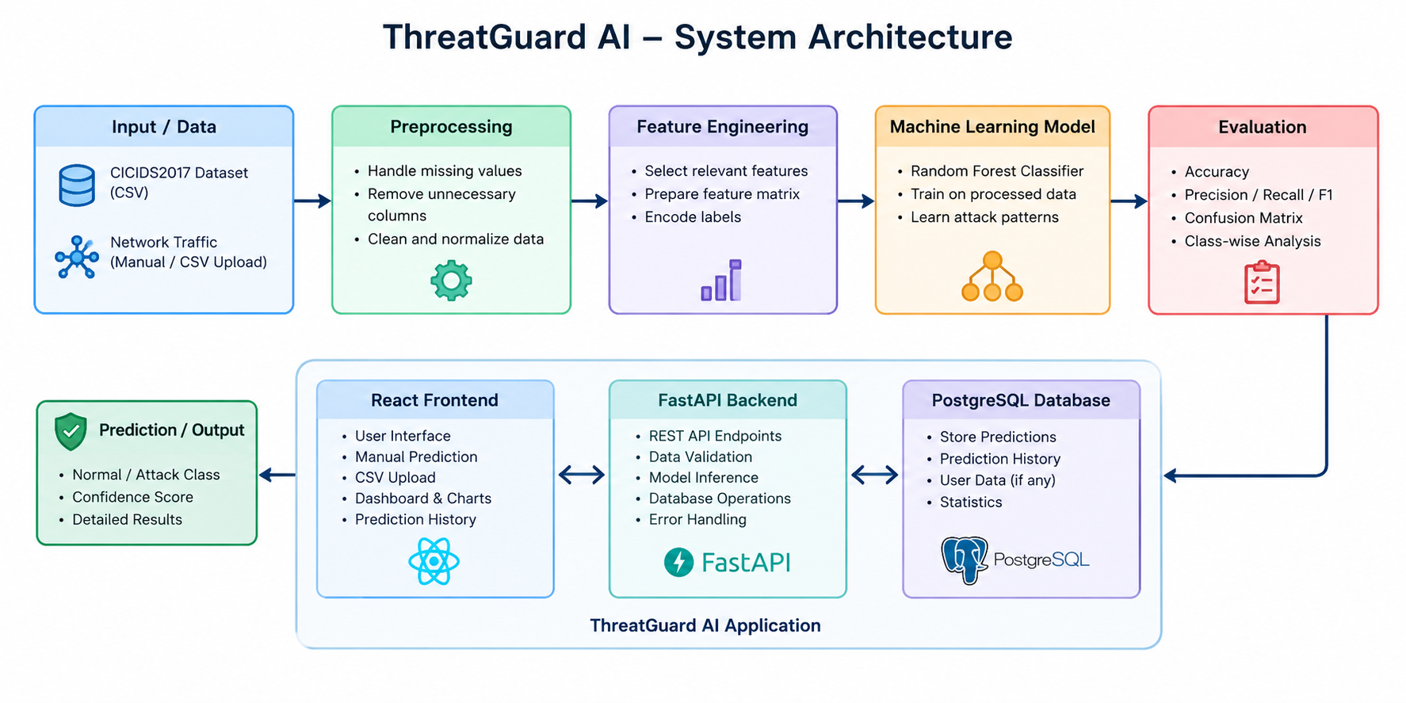

3.3 Methodology

The methodology followed in ThreatGuard AI consists of the following steps:

Dataset Collection – A 10,000-record subset of the CICIDS2017 network traffic dataset was used.

Data Understanding – The dataset was analysed to understand its features, target classes, distributions, and correlations.

Data Preprocessing – Invalid values were identified and missing values were handled before model training.

Feature Selection – Highly correlated and redundant features were analysed. Subflow Fwd Bytes was removed because it was completely correlated with Total Length of Fwd Packets.

Data Splitting – The cleaned dataset was divided into training and testing sets using an 80:20 stratified split.

Model Development – A Random Forest classifier was trained using the processed training data.

Model Evaluation – The model was evaluated using accuracy, precision, recall, F1-score, and confusion matrix.

Backend Integration – The trained model was integrated into a FastAPI backend for prediction requests.

Database Integration – Prediction results were stored in PostgreSQL.

Frontend Integration – A React dashboard was developed to submit data and display prediction results and analytics.

3.4 Development Phases

Phase 1: Problem Understanding & Objective Definition

The project began by identifying the need for automated classification of network traffic into normal and malicious categories. The main objective was to develop a machine learning model and integrate it into an accessible full-stack application.

Phase 2: Data Collection & Understanding
The CICIDS2017 dataset was selected as the source of network traffic data. A subset containing 10,000 records was used for the project. Exploratory analysis was performed to understand feature distributions, class distribution, and relationships between numerical features.

Phase 3: Data Preprocessing & Feature Engineering

The dataset was cleaned by handling invalid values and removing a highly redundant feature. Numerical features were processed using median imputation and standardization. The target labels were encoded for model training.

Phase 4: Model Building
Multiple classification approaches were considered during experimentation, including Logistic Regression and Random Forest-based models. The final system uses a Random Forest classifier with balanced class weighting.

Phase 5: Model Evaluation & Validation

The trained model was evaluated using a held-out test set containing 2,000 records. Accuracy, precision, recall, F1-score, and confusion matrix were used to analyse the model's performance. Stratified cross-validation was also performed to assess performance across different training-validation splits.

Phase 6: Final Output / Deployment

The trained model was integrated into a FastAPI backend and connected to a PostgreSQL database. A React dashboard was developed to allow users to submit traffic data, view predictions, inspect prediction history, and analyse attack statistics.

3.5 Dataset Description
The project uses a subset of the CICIDS2017 network intrusion dataset. For this project, 10,000 network traffic records were selected. Each record contains numerical features describing characteristics of network flows, along with an Attack Type label representing the traffic category.
The original dataset contains 53 columns, consisting of 52 input features and one target column. During preprocessing, one highly redundant feature, Subflow Fwd Bytes, was removed, resulting in 51 features used by the final machine learning model.

Table 3.5.1: Dataset Description
Parameter | Description
Dataset | CICIDS2017
Number of Records | 10,000
Original Columns | 53
Features Used | 51
Target Variable | Attack Type
Number of Classes | 7
Data Type | Numerical network-flow data
Training Data | 8,000 records
Testing Data | 2,000 records
Split Method | Stratified 80:20 split

Table 3.5.2: Class Distribution
Class | Number of Records | Percentage
Normal Traffic | 8,325 | 83.25%
DoS | 737 | 7.37%
DDoS | 539 | 5.39%
Port Scanning | 353 | 3.53%
Brute Force | 32 | 0.32%
Bots | 10 | 0.10%
Web Attacks | 4 | 0.04%
Total | 10,000 | 100%
3.6 Data Preprocessing
Data preprocessing was performed to prepare the raw network traffic features for machine learning.
3.6.1 Handling Invalid Values
The Flow IAT Min feature contained negative values, which were considered invalid for the modelling process. These values were replaced with missing values so that they could be handled during preprocessing.
The features Init_Win_bytes_forward and Init_Win_bytes_backward contained -1 values representing unavailable or sentinel values. These values were retained rather than treating them as ordinary missing values.

3.6.2 Removing Redundant Features
Correlation analysis was performed to identify highly related features. Subflow Fwd Bytes was removed because it had a correlation of 1.0 with Total Length of Fwd Packets, making it redundant for the model.This reduced the number of features from 52 to 51 before model training.

3.6.3 Handling Missing Values

Missing values generated during preprocessing were handled using median imputation. The median value of the corresponding training feature was used to replace missing values.

3.6.4 Feature Scaling

The numerical features were standardized using StandardScaler. This transforms the feature values to a common scale and ensures consistent preprocessing between training data and new prediction inputs.

3.6.5 Target Encoding

The categorical Attack Type labels were converted into numerical labels using LabelEncoder. The seven classes were encoded as follows:
Attack Type | Encoded Label
Bots | 0
Brute Force | 1
DDoS | 2
DoS | 3
Normal Traffic | 4
Port Scanning | 5
Web Attacks | 6

3.6.6 Train-Test Split

The dataset was divided into training and testing sets using an 80:20 stratified split. The training set contained 8,000 records, while the test set contained 2,000 records.

Stratification was used to preserve the class distribution between the training and testing datasets.

3.7 Feature Engineering

The dataset contains network-flow characteristics such as packet counts, packet lengths, flow duration, inter-arrival times, header lengths, packet rates, TCP flag counts, and window-size information.

Correlation analysis was performed to identify redundant features. Several feature pairs showed very high correlation, including:

Flow Duration and Fwd IAT Total

Flow IAT Max and Fwd IAT Max

Packet Length Mean and Average Packet Size

Total Length of Fwd Packets and Subflow Fwd Bytes

Flow Packets/s and Fwd Packets/s

Based on this analysis, Subflow Fwd Bytes was removed from the final feature set because it was perfectly correlated with another feature.

No manually created domain-specific features were added. The final model uses the processed 51 network-flow features from the original dataset.

3.8 Model Development

The project evaluated different machine learning approaches before selecting the Random Forest model for the final application.

3.8.1 Logistic Regression

Logistic Regression was evaluated as a baseline classification model. It provided an accuracy of approximately 88.3% on the test data.

3.8.2 Random Forest

Random Forest was selected for the final implementation because it provided substantially stronger classification performance on the given dataset.

The final model uses:

200 decision trees

class_weight = balanced

random_state = 42

Parallel processing using n_jobs = -1

3.9 Evaluation Metrics

The model was evaluated using multiple classification metrics to provide a more complete understanding of its performance.

Accuracy

Accuracy represents the proportion of correctly classified samples among all test samples.

Accuracy = Correct Predictions / Total Predictions

The final Random Forest model achieved 99.55% accuracy on the 2,000-sample held-out test set.

Precision

Precision measures how many samples predicted as a particular class actually belong to that class.

Precision = True Positives / (True Positives + False Positives)

Recall

Recall measures how many actual samples belonging to a class were correctly identified.

Recall = True Positives / (True Positives + False Negatives)

F1-Score

F1-score combines precision and recall using their harmonic mean.

F1 = 2 × (Precision × Recall) / (Precision + Recall)

The final model achieved a macro F1-score of 0.76 on the held-out test set.

Confusion Matrix

A confusion matrix was used to analyse class-wise predictions by comparing actual labels with predicted labels. It helps identify which traffic categories are correctly classified and where misclassifications occur.

Cross-Validation

Three-fold stratified cross-validation was also performed. The macro F1-scores obtained were approximately 0.709, 0.692, and 0.709, giving a mean macro F1-score of approximately 0.703.

The lower macro F1 compared with the overall accuracy reflects the strong class imbalance and the limited number of samples available for some attack categories.

CHAPTER 4

IMPLEMENTATION AND RESULTS

4.1 Development Environment

ThreatGuard AI was implemented using a combination of machine learning, backend, frontend, and database technologies. Model development and experimentation were carried out using Python, while the application was developed using FastAPI and React.
  Component
  Technology / Tool
  Programming Languages
  Python, JavaScript
  Machine Learning
  Scikit-learn
  Data Processing
  Pandas, NumPy
  Model Serialization
  Joblib
  Backend Framework
  FastAPI
  Frontend Framework
  React
  Build Tool
  Vite
  Database
  PostgreSQL
  API Communication
  Axios
  Data Visualization
  Recharts
  CSV Processing
  Papa Parse
  Development Environment
  Visual Studio Code
 | Google Colab
  ML Experimentation
Version Control | Git, GitHub

The machine learning model was developed using Python and Scikit-learn. The final trained model and supporting files were serialized using Joblib and integrated into the FastAPI backend. The React frontend communicates with the backend through REST APIs, while PostgreSQL stores prediction information.

4.2 Implementation

The implementation of ThreatGuard AI is divided into multiple modules that work together to provide the complete network traffic classification system.

4.2.1 Data Loading and Preprocessing Module

The dataset is loaded using Pandas and analysed to identify feature types, class distributions, invalid values, and highly correlated features.

The preprocessing pipeline performs:

Handling of invalid Flow IAT Min values.

Median imputation for missing values.

Removal of the redundant Subflow Fwd Bytes feature.

Standardization of numerical features.

Encoding of target labels.

Stratified train-test splitting.

4.2.2 Model Training Module

A Random Forest classifier is used as the final classification model. The classifier consists of 200 decision trees and uses balanced class weights to account for the imbalance in the dataset.

The trained pipeline is saved as:

threatguard_model.pkl

label_encoder.pkl

feature_names.pkl

These files are loaded by the backend when the application starts.

4.2.3 FastAPI Backend

FastAPI provides the application programming interface between the frontend, machine learning model, and database.

The major API endpoints are:

Table 4.2.1: Backend API Endpoints
  Endpoint
  Method
  Purpose
  /
  GET
  Checks whether the API is running
  /health
  GET
  Checks backend and database health
  /features
  GET
  Returns the required model features
  /predict
  POST
  Performs network traffic classification
  /predictions
  GET
  Retrieves prediction history
  /predictions/{id}
  GET
  Retrieves a specific prediction
/stats |  | Returns prediction and attack statistics
  GET

4.2.4 PostgreSQL Database

PostgreSQL is used to maintain prediction records generated by the application.

The predictions table contains:
Column | Description
id | Unique prediction identifier
prediction | Predicted traffic category
created_at | Prediction timestamp
confidence | Maximum predicted class probability
input_features | Input network-flow features stored as JSON

4.2.5 React Dashboard

The React frontend provides the main user interface for ThreatGuard AI.

The dashboard includes:

Backend and database health status

Total prediction count

Attack count

Normal traffic count

Attack rate

Average confidence

Latest prediction status

Attack category breakdown

Prediction history

Prediction details

Manual feature-based prediction

CSV upload and validation

The interface communicates with the FastAPI backend using Axios.

4.2.6 CSV-Based Classification

The system supports CSV-based network traffic testing. The uploaded file is validated against the required model features before a prediction is performed.

The frontend:

Reads the uploaded CSV file.

Validates the required feature columns.

Ignores non-model fields such as Attack Type.

Allows the user to select a record.

Validates the selected feature values.

Sends the selected record to the backend.

Displays the prediction and confidence.

This provides a convenient way to test multiple network traffic records without manually entering all feature values.

4.3 Experimental Results

The final Random Forest model was evaluated using a held-out test set containing 2,000 records.

Table 4.3.1: Final Model Performance
Metric | Result
Test Samples | 2,000
Number of Features | 51
Accuracy | 99.55%
Macro F1-Score | 0.76
Cross-Validation Mean Macro F1 | 0.703

Table 4.3.2: Class-wise Test Performance
Class | Precision | Recall | F1-Score | Support
Bots | 0.50 | 0.50 | 0.50 | 2
Brute Force | 0.75 | 1.00 | 0.86 | 6
DDoS | 1.00 | 1.00 | 1.00 | 108
DoS | 1.00 | 0.98 | 0.99 | 147
Normal Traffic | 1.00 | 1.00 | 1.00 | 1665
Port Scanning | 0.99 | 1.00 | 0.99 | 71
Web Attacks | 0.00 | 0.00 | 0.00 | 1
Macro Average | 0.75 | 0.78 | 0.76 | 2000

Figure 4.3.1: Confusion Matrix of the Final Random Forest Model

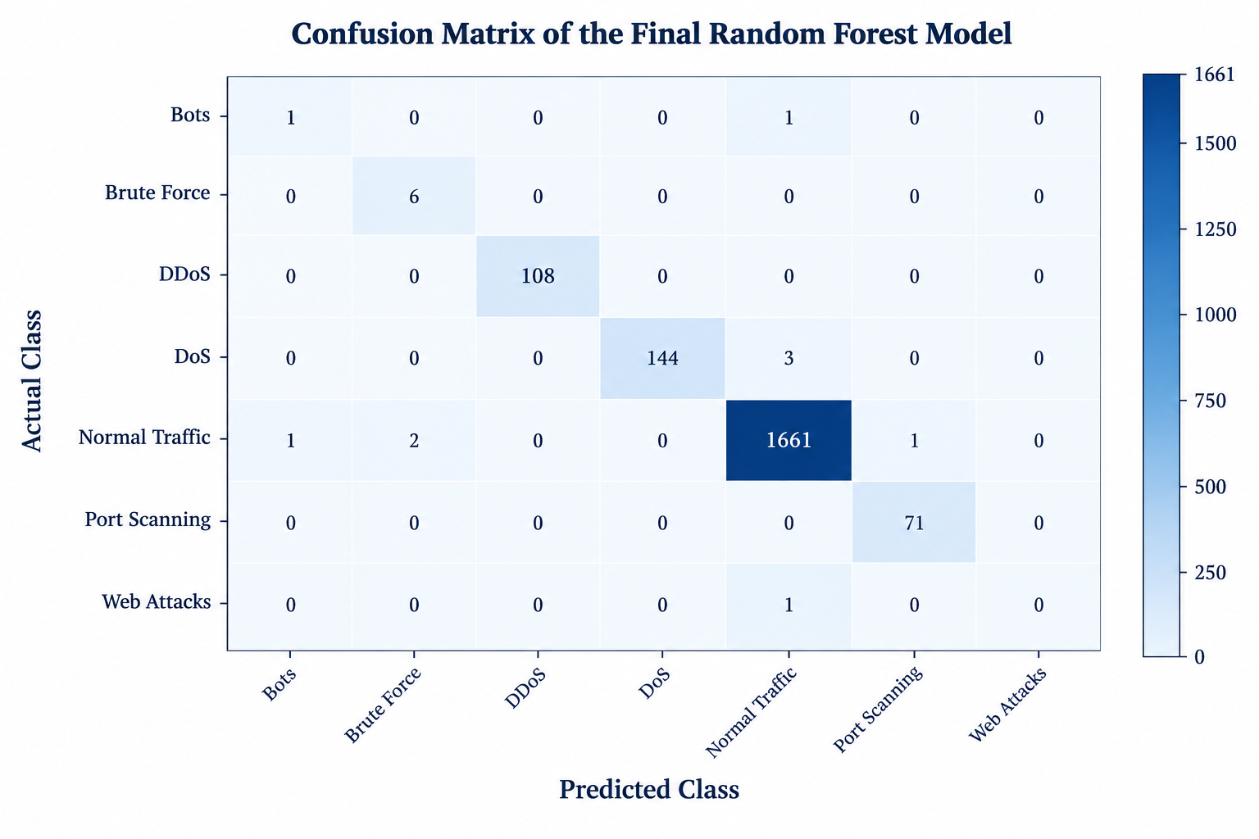The confusion matrix can be used to visually represent the relationship between actual and predicted traffic classes.

4.4 Model Comparison
Table 4.4.1: Model Performance Comparison
Model | Accuracy | Observation
Logistic Regression | 88.3% | Lower classification performance
Random Forest | 99.55% | Selected for final implementation
Balanced Random Forest | 99.5% | Comparable performance

4.5 Output / Screenshots

Figure 4.5.1: ThreatGuard AI Dashboard

Shows the main dashboard containing prediction statistics, attack rate, confidence information, and traffic classification information.

Figure 4.5.2: Manual Traffic Prediction

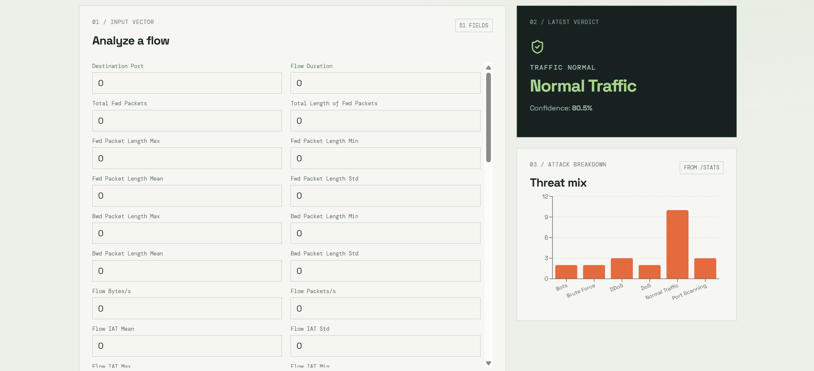Shows the interface for entering network-flow features and obtaining a classification result.

Figure 4.5.3: CSV Upload and Classification
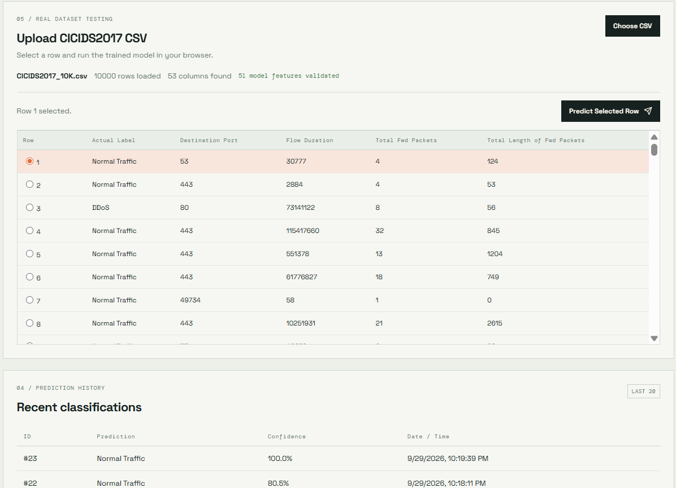

Figure 4.5.4: Prediction History
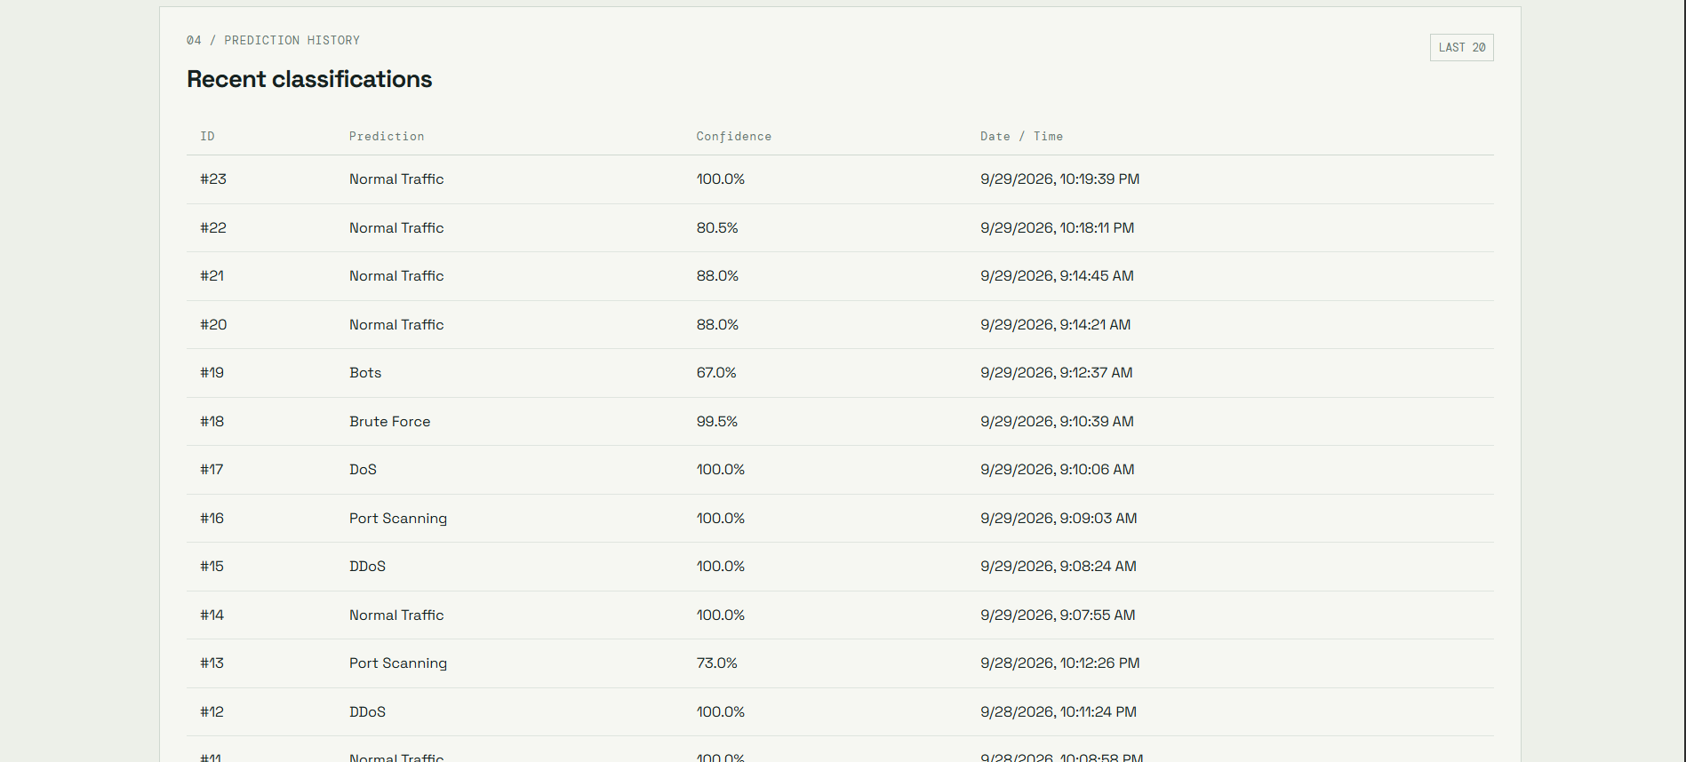

Figure 4.5.5: Prediction Details
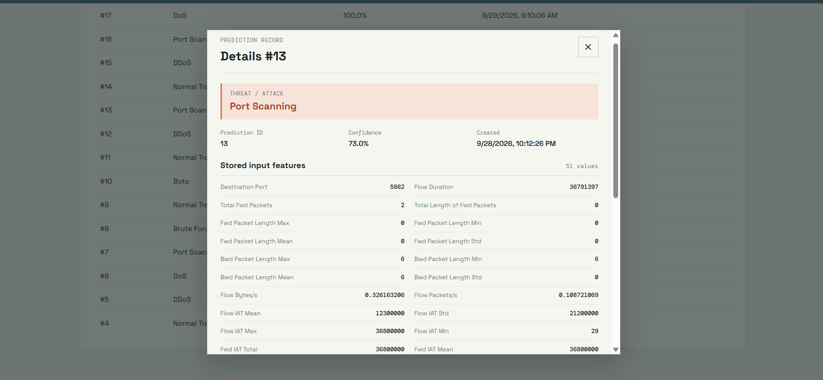

Figure 4.5.6: Attack Breakdown
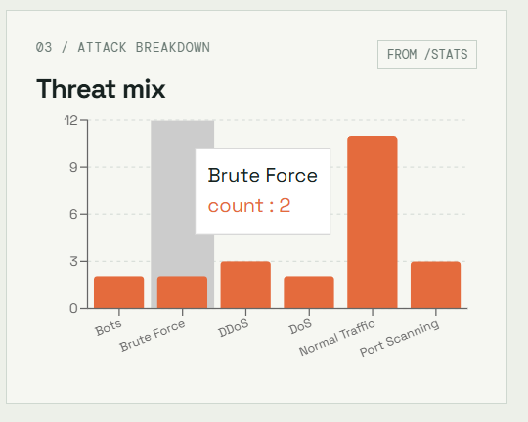

4.6 Discussion
The experimental results demonstrate that the developed Random Forest model can classify the network traffic records in the selected dataset with high overall accuracy. The model achieved 99.55% accuracy on the held-out test set and a macro F1-score of 0.76.
The class-wise results indicate that the model performs strongly on classes with sufficient representation, including Normal Traffic, DDoS, DoS, and Port Scanning. However, the results for smaller classes such as Bots and Web Attacks are less reliable because the test set contains only a very small number of samples from these categories.
The difference between the high accuracy and lower macro F1-score highlights the impact of class imbalance. Therefore, accuracy alone does not fully represent the model's performance across all attack categories.
The application successfully integrates the trained model with a FastAPI backend, PostgreSQL database, and React dashboard. The system provides a practical interface for submitting network traffic data, viewing predictions, examining historical results, and analysing traffic statistics.
One limitation of the current implementation is that it operates on supplied traffic records rather than capturing live network packets. In addition, the dataset contains severe class imbalance, particularly for Web Attacks and Bots. These limitations should be considered when interpreting the current results and when extending the system to larger real-world environments.

CHAPTER 5

CONCLUSION AND FUTURE ENHANCEMENT

5.1 Conclusion

ThreatGuard AI provides a machine learning-based approach for identifying and classifying network traffic into normal and attack categories. The system uses a Random Forest classifier trained on a 10,000-record subset of the CICIDS2017 dataset and classifies traffic into seven categories.

The final model achieved 99.55% accuracy and a macro F1-score of 0.76 on a held-out test set of 2,000 records. The model was integrated into a complete application using FastAPI, React, and PostgreSQL. The resulting system supports manual traffic classification, CSV-based testing, prediction history, confidence analysis, attack statistics, and detailed prediction inspection.

The project demonstrates the integration of machine learning with a full-stack application for network traffic analysis. At the same time, the class imbalance and limited samples available for certain attack categories indicate that the reported results should be interpreted with these limitations in mind.

5.2 Future Enhancement
The following improvements can be considered for future versions of ThreatGuard AI:
- Larger and balanced datasets: Incorporate additional network traffic datasets with greater representation of rare attack categories.
- Advanced machine learning models: Evaluate methods such as Gradient Boosting, XGBoost, or neural-network-based classifiers.
- Real-time network monitoring: Extend the system to capture and analyse live network traffic instead of relying only on uploaded or manually entered records.
- Improved feature engineering: Investigate additional network-specific features and feature-selection techniques to improve classification across minority classes.
- Cloud deployment: Deploy the application on a cloud platform to make the system accessible remotely and support scalable usage.
- Real-time alerting: Add notification mechanisms for detecting potentially malicious traffic.
- Model monitoring: Track model performance over time and support periodic retraining using newly collected traffic data.
- Enhanced security: Introduce additional authentication, authorization, and secure API communication mechanisms for production environments.

CHAPTER 6

REFERENCES

[1] Canadian Institute for Cybersecurity, “CICIDS2017 Dataset,” University of New Brunswick, Canada. Available: https://www.unb.ca/cic/datasets/ids-2017.html

[2] F. Pedregosa et al., “Scikit-learn: Machine Learning in Python,” Journal of Machine Learning Research, vol. 12, pp. 2825–2830, 2011.

[3] W. McKinney, Python for Data Analysis: Data Wrangling with Pandas, NumPy, and IPython, O’Reilly Media.

[4] NumPy Developers, “NumPy Documentation.” Available: https://numpy.org/doc/

[5] FastAPI, “FastAPI Documentation.” Available: https://fastapi.tiangolo.com/

[6] React Documentation, “React – The Library for Web and Native User Interfaces.” Available: https://react.dev/

[7] PostgreSQL Global Development Group, “PostgreSQL Documentation.” Available: https://www.postgresql.org/docs/

[8] Vite, “Vite Documentation.” Available: https://vite.dev/guide/

[9] Joblib Developers, “Joblib Documentation.” Available: https://joblib.readthedocs.io/

APPENDIX
A. MACHINE LEARNING MODEL
APPENDIX A.1 – Dataset Loading (evaluate_model.py)
# Load dataset
df = pd.read_csv("CICIDS2017_10K.csv")

APPENDIX A.2 – Data Preprocessing (evaluate_model.py, main.py)
X = df.drop(columns=["Attack Type"])
y = df["Attack Type"]
X = X.drop(columns=["Subflow Fwd Bytes"])
input_df.loc[
input_df["Flow IAT Min"] < 0,
"Flow IAT Min"
] = float("nan")

APPENDIX A.3 – Feature Selection (evaluate_model.py)
X = X.drop(columns=["Subflow Fwd Bytes"])

APPENDIX A.4 – Label Encoding (evaluate_model.py)
label_encoder = joblib.load(
"../backend/ml_models/label_encoder.pkl"
)
y_pred = label_encoder.inverse_transform(y_pred_encoded)
APPENDIX A.5 – Train-Test Split (evaluate_model.py)
X_train, X_test, y_train, y_test = train_test_split(
X,
y,
test_size=0.20,
random_state=42,
stratify=y
)

APPENDIX A.6 – Model Evaluation (evaluate_model.py)
accuracy = accuracy_score(y_test, y_pred)
print(f"\nTest samples : {len(X_test)}")
print(f"Features : {X_test.shape[1]}")
print(f"Accuracy : {accuracy:.4%}")
print("\nClassification Report:")
print(
classification_report(
y_test,
y_pred,
labels=label_encoder.classes_,
zero_division=0
)
)
print("\nConfusion Matrix:")
print(label_encoder.classes_)
print(confusion_matrix(
y_test,
y_pred,
labels=label_encoder.classes_
))

B. FASTAPI BACKEND
APPENDIX B.9 – Loading the Trained Model (main.py)
BASE_DIR = Path(__file__).resolve().parent
model = joblib.load(BASE_DIR / "ml_models" / "threatguard_model.pkl")
label_encoder = joblib.load(BASE_DIR / "ml_models" / "label_encoder.pkl")
feature_names = joblib.load(BASE_DIR / "ml_models" / "feature_names.pkl")

APPENDIX B.10 – Database Connection (main.py)
def get_db_connection():
return psycopg2.connect(
host=os.getenv("DB_HOST"),
port=os.getenv("DB_PORT"),
database=os.getenv("DB_NAME"),
user=os.getenv("DB_USER"),
password=os.getenv("DB_PASSWORD")
)

APPENDIX B.11 – Prediction API (POST /predict)
@app.post("/predict", response_model=PredictionResponse, status_code=status.HTTP_201_CREATED)
def predict(request: PredictionRequest):
input_data = request.features
missing_features = [
feature for feature in feature_names
if feature not in input_data
]
if missing_features:
raise HTTPException(
status_code=status.HTTP_422_UNPROCESSABLE_CONTENT,
detail={
"message": "Missing required features",
"missing_features": missing_features
},
)
input_values = [input_data[feature] for feature in feature_names]
input_df = pd.DataFrame([input_values], columns=feature_names)
input_df.loc[
input_df["Flow IAT Min"] < 0,
"Flow IAT Min"
] = float("nan")
prediction = model.predict(input_df)
confidence = float(max(model.predict_proba(input_df)[0]))
attack_type = label_encoder.inverse_transform(prediction)[0]
ordered_input_features = {
feature: input_data[feature]
for feature in feature_names}
try:
with get_db_connection() as conn:
with conn.cursor() as cursor:
cursor.execute(
"""
INSERT INTO predictions
(prediction, confidence, input_features)
VALUES (%s, %s, %s)
""",
(attack_type, confidence, Json(ordered_input_features)),
)
except psycopg2.Error as error:
raise HTTPException(
status_code=status.HTTP_503_SERVICE_UNAVAILABLE,
detail="Prediction was generated but could not be saved.",
) from error
return {
"prediction": attack_type,
"confidence": confidence
}

APPENDIX B.12 – Prediction History API (GET /predictions)
@app.get("/predictions", response_model=list[PredictionHistoryItem])
def prediction_history(
limit: int = Query(default=20, ge=1, le=100),
offset: int = Query(default=0, ge=0),
label: str | None = Query(default=None, min_length=1),
):
query = """
SELECT id, prediction, confidence, created_at
FROM predictions
"""
query_parameters: list[object] = []
if label is not None:
query += " WHERE prediction = %s"
query_parameters.append(label)
query += """
ORDER BY created_at DESC, id DESC
LIMIT %s OFFSET %s
"""
query_parameters.extend([limit, offset])
try:
with get_db_connection() as conn:
with conn.cursor() as cursor:
cursor.execute(query, tuple(query_parameters))
rows = cursor.fetchall()
except psycopg2.Error as error:
raise HTTPException(
status_code=status.HTTP_503_SERVICE_UNAVAILABLE,
detail="Prediction history is currently unavailable.",
) from error

APPENDIX B.13 – Statistics API (GET /stats)
cursor.execute(
"""
SELECT
COUNT(*) AS total_predictions,
COUNT(*) FILTER (
WHERE prediction = 'Normal Traffic'
) AS normal_traffic,
COUNT(*) FILTER (
WHERE prediction <> 'Normal Traffic'
) AS attacks,
AVG(confidence) AS average_confidence
FROM predictions
"""
)
totals = cursor.fetchone()
cursor.execute(
"""
SELECT prediction, COUNT(*) AS prediction_count
FROM predictions
GROUP BY prediction
ORDER BY prediction
"""
)
breakdown_rows = cursor.fetchall()

APPENDIX B.14 – Health Check API (GET /health)
@app.get("/health")
def health_check():
try:
with get_db_connection() as conn:
with conn.cursor() as cursor:
cursor.execute("SELECT 1")
cursor.fetchone()
except psycopg2.Error as error:
raise HTTPException(
status_code=status.HTTP_503_SERVICE_UNAVAILABLE,
detail="Database is unavailable.",
) from error
return {
"status": "healthy",
"database": "connected",
}

APPENDIX B.15 – Error Handling and Input Validation
class PredictionRequest(BaseModel):
features: dict[str, float] = Field(..., min_length=1)
class PredictionResponse(BaseModel):
prediction: str
confidence: float
if missing_features:
raise HTTPException(
status_code=status.HTTP_422_UNPROCESSABLE_CONTENT,
detail={
"message": "Missing required features",
"missing_features": missing_features,
},
)

C. POSTGRESQL DATABASE
APPENDIX C.16 – Database Schema (schema.sql)
CREATE TABLE IF NOT EXISTS predictions (
id SERIAL PRIMARY KEY,
prediction VARCHAR(100) NOT NULL,
created_at TIMESTAMP DEFAULT CURRENT_TIMESTAMP
);

APPENDIX C.17 – Prediction Table Migration (001_add_prediction_details.sql)
BEGIN;
ALTER TABLE predictions
ADD COLUMN IF NOT EXISTS confidence DOUBLE PRECISION;
ALTER TABLE predictions
ADD COLUMN IF NOT EXISTS input_features JSONB;
COMMIT;

D. REACT FRONTEND
APPENDIX D.18 – Main Application Component (App.jsx)
const API_BASE_URL = import.meta.env.VITE_API_BASE_URL;
const api = axios.create({ baseURL: API_BASE_URL });
function App() {
const [features, setFeatures] = useState([]);
const [values, setValues] = useState({});
const [history, setHistory] = useState([]);
const [stats, setStats] = useState(null);
const [health, setHealth] = useState({
status: 'checking',
database: 'checking'
});
const [prediction, setPrediction] = useState(null);
const loadData = async () => {
const results = await Promise.allSettled([
api.get('/features'),
api.get('/predictions', {
params: { limit: 20, offset: 0 }
}),
api.get('/stats'),
api.get('/health'),
]);
// Successful results update their corresponding dashboard state.
};
useEffect(() => { loadData(); }, []);

APPENDIX D.19 – API Integration Using Axios (App.jsx)
const API_BASE_URL = import.meta.env.VITE_API_BASE_URL;
const api = axios.create({ baseURL: API_BASE_URL });
const runPrediction = async (requestFeatures) => {
const { data } = await api.post('/predict', {
features: requestFeatures
});
setPrediction(data);
await loadData();
};

APPENDIX D.20 – Manual Prediction (App.jsx)
const submitPrediction = async (event) => {
event.preventDefault();
setBusy(true);
setError('');
try {
const requestFeatures = Object.fromEntries(
features.map((name) => [
name,
Number(values[name]) || 0
])
);
await runPrediction(requestFeatures);
} catch (requestError) {
setError(getRequestMessage(
requestError,
'Prediction failed. Check the entered values.'
));
} finally {
setBusy(false);
}
};

APPENDIX D.21 – CSV Upload and Validation (App.jsx)
Papa.parse(file, {
header: true,
skipEmptyLines: true,
complete: (results) => {
const columns = (results.meta.fields || [])
.map((column) => column.replace(/^\uFEFF/, ''));
const rows = results.data.map((row) =>
Object.fromEntries(
Object.entries(row).map(([key, value]) => [
key.replace(/^\uFEFF/, ''),
value
])
)
);
const missingFeatures = features.filter(
(feature) => !columns.includes(feature)
);
if (results.errors.length) {
setCsvError(
'The CSV could not be parsed. Check its formatting and try again.'
);
} else if (!rows.length) {
setCsvError(
'The CSV does not contain any data rows.'
);
} else if (missingFeatures.length) {
setCsvError(
`The CSV is missing required model features: ${missingFeatures.join(', ')}`
);
} else {
setCsvColumns(columns);
setCsvRows(rows);
}
setCsvLoading(false);
},
error: () => {
setCsvError(
'The CSV could not be parsed. Check its formatting and try again.'
);
setCsvLoading(false);
},
});

APPENDIX D.22 – Prediction History (App.jsx)
api.get('/predictions', {
params: { limit: 20, offset: 0 }
});
<tbody>
{history.length ? history.map((item) => (
<tr key={item.id}>
<td>#{item.id}</td>
<td>{item.prediction}</td>
<td>{formatConfidence(item.confidence)}</td>
<td>{formatDateTime(item.created_at)}</td>
</tr>
)) : (
<tr>
<td colSpan="4" className="empty-history">
{loading
? 'Loading prediction history...'
: 'No prediction history available.'}
</td>
</tr>
)}
</tbody>

APPENDIX D.23 – Dashboard Statistics and Charts (App.jsx)
const chartData = useMemo(() => {
return Object.entries(stats?.attack_breakdown || {}).map(
([name, count]) => ({ name, count })
);
}, [stats]);
<ResponsiveContainer width="100%" height={220}>
<BarChart data={chartData}>
<CartesianGrid strokeDasharray="3 3" />
<XAxis dataKey="name" />
<YAxis allowDecimals={false} />
<Tooltip />
<Bar dataKey="count" fill="#e46b3d" />
</BarChart>
</ResponsiveContainer>

APPENDIX D.24 – Prediction Details (App.jsx)
const openPredictionDetail = async (predictionId) => {
setSelectedPredictionId(predictionId);
setPredictionDetail(null);
setDetailError('');
setDetailLoading(true);
try {
const { data } = await api.get(
`/predictions/${predictionId}`
);
setPredictionDetail(data);
} catch (requestError) {
const message = requestError.response?.status === 404
? 'This prediction could not be found.'
: getRequestMessage(
requestError,
'Prediction details could not be loaded.'
);
setDetailError(message);
} finally {
setDetailLoading(false);
}
};
<div className="detail-features">
{features.map((feature) => (
<div className="detail-feature" key={feature}>
<span>{feature}</span>
<strong>
{predictionDetail.input_features?.[feature] ?? '--'}
</strong>
</div>
))}
</div>

E. PROJECT CONFIGURATION
APPENDIX E.25 – Backend Requirements (requirements.txt)
fastapi
joblib
pandas
psycopg2-binary
python-dotenv
scikit-learn
uvicorn[standard]

APPENDIX E.26 – Frontend Package Configuration (package.json)
{
"name": "threatguard-dashboard",
"private": true,
"version": "1.0.0",
"type": "module",
"scripts": {
"dev": "vite",
"build": "vite build",
"preview": "vite preview"
},
"dependencies": {
"@vitejs/plugin-react": "latest",
"axios": "latest",
"lucide-react": "latest",
"papaparse": "^5.7.0",
"react": "latest",
"react-dom": "latest",
"recharts": "latest",
"vite": "latest"
},
"devDependencies": {}
}

